INSTRUCTIONS TO FILL IN THE APPLICATION FORM
Fill each and every section of this document with as much detail as you can, following the instructions given.
- Please prepare the ISON Telescope Provision Application Form in accordance with the instruction and guidelines given in this template. Please refer to the Announcement of Opportunity (hereinafter the ''AO'') for the baseline requirements.
- Make the descriptions in the documents specific and comprehensive utilizing charts and tables. Please reference in the text all charts, figures and tables used.
- The template has two types of fields to be filled in:
      - Mandatory: mandatory fields are marked with the following code [M].
      - Optional: optional fields are marked with the following code [O].
Please include your text where indicated.
- When necessary, sections and subsections will contain a description of their expected content. Descriptions are marked with the code [DESCRIPTION]. Please use any graphic material such as diagrams when you deem them necessary to clarify or express a concept or a design.
- Write “TBD” when information is not yet available on an item.
- Using the provided Word templates is required. The application should follow the following general format:
      - Size of paper: A4
      - Margins: 20 mm from the edge
      - Page number: 15 mm from the bottom edge
      - Font and size: Times New Roman 10-12 points
      - The application should be submitted in .pdf (it shall be possible to select text in the pdf file).
- Please do not include this page in your application.

IMPORTANT: The application is only considered valid if all the information requested from Announcement of Opportunity is provided.

Table of Contents
Table of Contents 2
1. BASIC INFORMATION [M] 3
1.1. Project Title: [M] 3
1.2. Executive Summary: (no more than 900 characters) [M] 3
1.3. Certificate [M] 4
1.4. Project Coordinator Information [M] 5
2. TEAM COMPOSITION 6
2.1. Project Coordinator [M] 6
2.2. Team Member [M] 7
3. PROPOSAL ABSTRACT [M] 9
4. MISSION OBJECTIVES, REQUIREMENTS AND CONSTRAINTS 9
4.1. Objectives [M] 9
4.2. Relevance to the Sustainable Development Goals [M] 9
5. SITE DESCRIPTION AND OPERATIONS 9
5.1. Location Information [M] 9
5.2. Telescope Hosting [M] 11
5.3. Control Room [M] 11
5.4. Additional Equipment and Capabilities [M] 12
5.4.1. Internet Connection [M] 12
5.4.2. Electrical Power [M] 12
5.4.3. CMOS/CCD Camera [O] 12
5.4.4. Other Equipment [O] 12
5.5. Concept of Operations [M] 12
5.6. Foreseen Outcomes and Deliverables [O] 13
6. SCHEDULE 13
6.1. Development Schedule [M] 13
7. LICENSING 13
7.1. Licenses for Site Construction [O] 13
7.2. Other Licenses Required [O] 13
8. BUDGET 14
8.1. Total Cost [M] 14
8.2. Secured Budget and Budget Plan [M] 14
9. FEASIBILITY AND RISK ANALYSIS 14
9.1. Feasibility Analysis [M] 14
9.2. Risk Analysis [M] 14
10. COMMUNICATIONS AND DISSEMINATION PLAN [M] 15
11. SUPPORTING DOCUMENTS [M] 15
12. ABBREVIATIONS AND REFERENCES [M] 15

BASIC INFORMATION [M]

Status of your organization(s) (using “X” as appropriate):
[ ] Research institutions [ ] Universities [ ] other public institutions
[ ] International Organization

Project Title: [M]
TITLE OF THE PROJECT HERE

Executive Summary: (no more than 900 characters) [M]
EXECUTIVE SUMMARY HERE

Certificate [M]
By signing this application, I confirmed that all statements in our application are true, correct and complete. Once selected, our organizations(s) will comply with the Terms and Conditions stipulated in the Announcement of Opportunity:
Issued by the Project Coordinator (PC):

Name of PC in print |  | Signature of PC |  | Place |  | Date (dd-mm-yyyy)

Approved by Applying Organization 1:
(Signature of Head of Applying Organization 1) |  | Place |  | Date (dd-mm-yyyy)

_____________________________________________ _________________________
(Full name and title of Head of Applying Organization 1 in print) (Seal of Applying Organization 1)

Approved by Applying Organization 2 (if applicable, and extend this section as needed for more organizations):
(Signature of Head of Applying Organization 2) |  | Place |  | Date (dd-mm-yyyy)

_________________________________________________ _____________________________
(Full name and title of Head of Applying Organization 2 in print) (Seal of Applying Organization 2)

Project Coordinator Information [M]
Name and Surname
Gender
Telephone
E-mail
Legal Name of Project Coordinator’s Organization
Address of Project Coordinator’s Organization

TEAM COMPOSITION

Project Coordinator [M]
Name and Surname
Gender
Nationality
Job title
Telephone
E-mail
Legal Name of Project Coordinator’s Organization
Full Address of Project Coordinator’s Organization (including country)
List of papers published by the Project Coordinator in peer-reviewed journals related to the topic of the proposal (if none, please insert N/A)
Experience (if none, please insert N/A)
Has the Project Coordinator been part of a winner team of other competitive process organized by UNOOSA? (e.g. DropTES, KiboCUBE, CSS,…) | [ ] Yes [ ] No  If yes please explain:

Mini CV:
YOUR TEXT HERE

Team Member [M]
([DESCRIPTION] Repeat this section as necessary to cover all the team members.).
Name and Surname
Gender
Nationality
Telephone
E-mail
Legal Name of Team Member’s Organization
Full Address of Team Member’s Organization (including country)
Legal Name of Team Member’s Organization (if different from Project Coordinator’s Organization)
Full Address of Team Member’s Organization (including country) (if different from Project Coordinator’s Organization)
List of papers published by the team member in peer reviewed journals related to the topic of the proposal (if none, please insert N/A)
Experience (if none, please insert N/A)
Has the Team Member been part of a winning team of other competitive process organized by UNOOSA? (e.g. DropTES, KiboCUBE, CSS,…) | [ ] Yes [ ] No  If yes please explain:
Mini CV:
YOUR TEXT HERE

PROPOSAL ABSTRACT [M]
([DESCRIPTION] Please insert a brief description of the proposed research activities to be carried out with the telescope, stating the objectives and aim of the research. The abstract should also concisely describe the prospective site for the telescope installation. Maximum 300 words.).
YOUR TEXT HERE

MISSION OBJECTIVES, REQUIREMENTS AND CONSTRAINTS

Objectives [M]
([DESCRIPTION] Please list the scientific and educational objectives for which the telescope will be used, please use SMART (Specific, Measurable, Achievable, Relevant, Time-bounded). Objectives can be categorized in primary and secondary (may be achieved once the primary objectives are achieved). Primary objectives and secondary objectives shall be numbered as PrimObj-XXX and SecObj-XXX respectively (e.g. PrimObj-001, PrimObj-002…; SecObj-001, SecObj-002…).
YOUR TEXT HERE

Relevance to the Sustainable Development Goals [M]
([DESCRIPTION] Please insert a description of the Sustainable Development Goals that are supported by the activities to be carried out with the telescope and its associated expected results. Please indicate how the participation in the AO and its related activities contribute to one or several Sustainable Development Goals).
YOUR TEXT HERE

SITE DESCRIPTION AND OPERATIONS

Location Information [M]
([DESCRIPTION] Please insert a description of the location of the telescope hosting facility, including geodetic coordinates of the site (WGS 84), the amount of light pollution (Bortle scale and/or mag/arcsec2), description of possible nearby light sources, an average number of clear night hours per year, station visibility diagram (azimuth-elevation mask)*, available infrastructure (e.g. road, electricity supply, connectivity, lodging, etc.).
YOUR TEXT HERE

*For the station visibility diagram use the following template, where the centre of the diagram corresponds to the altitude equal to 90º, concentric circles are lines of equal angles of altitude, radial lines show the azimuth angles (east is azimuth 90°, south is azimuth 180°, and west is azimuth 270°).
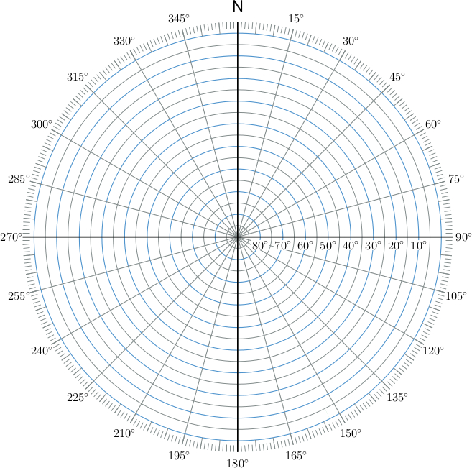
An example:
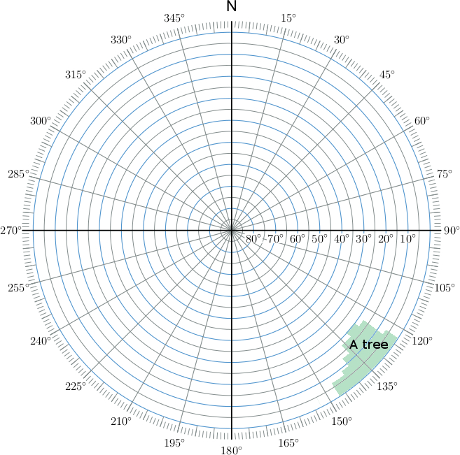

Telescope Hosting [M]
([DESCRIPTION] Please insert a description of the telescope shelter (dome, pavilion, etc.), including dimensions, floor plan, type of the roof (rotating dome, roll-off roof, etc.).).
YOUR TEXT HERE

Control Room [M]
([DESCRIPTION] The control room is for the telescope routine operation and (optionally) obtained data processing. Please insert a description of the control room setup and location relative to the telescope.).
YOUR TEXT HERE

Additional Equipment and Capabilities [M]

Internet Connection [M]
([DESCRIPTION] Please insert a description of the Internet connection for the control room and the telescope hosting, if different.).
YOUR TEXT HERE

Electrical Power [M]
([DESCRIPTION] Please insert a description of the electrical power system, including voltage, grounding system, maximum capacity (kWh), specifications of available uninterruptible power supplies.).
YOUR TEXT HERE

CMOS/CCD Camera [O]
([DESCRIPTION] Please insert a description of the CCD/CMOS camera if available, including model, sensor type, sensor size, pixel size, or budget available to purchase one.).
YOUR TEXT HERE

Other Equipment [O]
([DESCRIPTION] Please insert a description (model, specifications) of available equipment, which consistent with items in the list of the equipment compliant with ISON.).
YOUR TEXT HERE

Concept of Operations [M]
([DESCRIPTION] Please insert a description of how the telescope will be operated, e.g. operational schedule (e.g. weekdays only, every night, etc.), availability of operators during the routine observing night, the estimated average number of observing nights per year, an average number of person-hours available daily for data processing.).
YOUR TEXT HERE

Foreseen Outcomes and Deliverables [O]
([DESCRIPTION] Please insert a description of the specific outcomes of the research using the telescope and how they are related to the Sustainable Development Goals.).
YOUR TEXT HERE

SCHEDULE

Development Schedule [M]
([DESCRIPTION] Please provide a schedule for the preparation of the site for the telescope installation, including milestones and pass/fail criteria for each phase, a corresponding Gantt chart and its description. Availability of the elements described in Section 5 (e.g. electricity supply, internet connection, equipment availability, etc.) should be taken into account.).
YOUR TEXT HERE

LICENSING

Licenses for Site Construction [O]
([DESCRIPTION] Please provide, if applicable, information concerning the licenses to build the facility for the telescope installation and when the expected timeline to get them.).
YOUR TEXT HERE

Other Licenses Required [O]
([DESCRIPTION] Please provide information concerning the any other license to be requested for the operations and the plan to obtain the license(s) (times, entity(ies), etc.).
YOUR TEXT HERE

BUDGET

Total Cost [M]
([DESCRIPTION] Please provide information on the total budget available for the project implementation and budget on each item, including the cost of the telescope and facility maintenance and operation, personnel costs, travel expenses, dissemination activities, etc.). Please, detail budget on each item. This section can be split in two, budget on preparatory work and budget on operation.).
YOUR TEXT HERE

Secured Budget and Budget Plan [M]
([DESCRIPTION] Please provide information of the secured budget and letters of commitment specifying the funding source, and information on what are the envisaged funding sources of any remaining non-secured budget.).
YOUR TEXT HERE

FEASIBILITY AND RISK ANALYSIS

Feasibility Analysis [M]
([DESCRIPTION) Provide arguments on the feasibility of your project.).
YOUR TEXT HERE

Risk Analysis [M]
([DESCRIPTION) Provide a description of the risks that you might face, their likelihood (1 (not likely) to 3 (very likely) and impact (1 (minor impact) to 3 (catastrophic)) and mitigation actions for each of them.).
YOUR TEXT HERE

COMMUNICATIONS AND DISSEMINATION PLAN [M]
([DESCRIPTION) Provide the plan (e.g. scope, schedule, resources, means) that will be used to promote the opportunity and the results. Particular attention should be given to initiatives inside the applicant country(ies).).
YOUR TEXT HERE

SUPPORTING DOCUMENTS [M]
([DESCRIPTION) List here any documents in support of your application (e.g. support letters, CVs,…), including document number, document name, authors and organizations, publication and volume, date, etc. Please attach those documents as separate pdf files (they could be scan copies of originals if needed).).
YOUR TEXT HERE

ABBREVIATIONS AND REFERENCES [M]
([DESCRIPTION) List here any abbreviations used across the document and references of documentation you have used to create your application (including document number, document name, authors and organizations, publication and volume, date, etc.).
YOUR TEXT HERE

