Instrumental Aid by Japanese Official Development Assistance for Astronomy in Developing Countries*
(Part II)

Masatoshi Kitamura

National Astronomical Observatory

Mitaka, Tokyo 181-8588, Japan

Abstract

In order to promote education and research in developing countries, the Japanese Government has been providing developing countries with high-grade equipment under the framework of the Official Development Assistance (ODA) cooperation programme since 1982. Under this successful cooperation programme, 24 astronomical instruments have been donated to 19 developing countries up to the end of the Japanese fiscal year 2003. The instruments donated included university-level reflecting telescopes, as well as modern planetaria used for educational purposes, together with various accessories.

This paper describes a continuation of the previous ODA donations (Astronomical Herald 1997) and the subsequent follow-up programmes provided with the assistance of Japan International Cooperation Agency (JICA).

- Necessity of astronomical equipment in developing countries

The current number of science students in developing countries is rapidly increasing. In addition, a good number of them attend Ph.D. courses at universities or science institutes in order to further pursue higher education. Many of these science students are aware of the fact that the present age is often called the “space age” or “cosmic age” and become therefore very interested in the subject of space and the universe.

Similarly, the number of highly educated professionals in astronomy is also steadily increasing in developing countries; however, most developing countries unfortunately do not have the adequate astronomical equipment so urgently needed for education and research purposes that such professionals could use. One example of the need to support cooperation programmes providing adequate astronomical equipment to developing countries is that old-fashioned refracting telescopes are still used in a good number of developing countries. There is still a great lack of modern high-grade reflecting telescopes of higher quality and better resolution that could be used to better observe the skies.

A similar situation is also encountered with planetaria and their related equipment. Planetaria are very important and necessary tools for a good education in astronomy. Nevertheless, only a limited number of developing countries have available old-type planetaria located in their capital cities. On the other hand, industrialized countries have built a considerable number of planetaria that are used for space education not only in their capital cities, but also in towns, schools and other places. For example, there are approximately 500 planetaria in the United States of America and 361 in Japan.

Therefore, in order to not only promote and support space education and university high-level research, but also raise global awareness of the need for adequate astronomical equipment in developing countries, financial assistance from developed, industrialized countries would be most important and welcome in the field of astronomy.

- Japanese ODA for Astronomy

In 1986, the Japanese Government made its first donation through the ODA in the form of a planetarium to Myanmar.

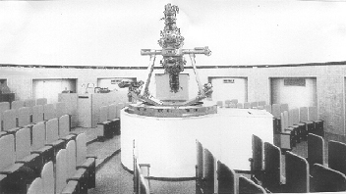

Fig. 1: Inside of Yangon Planetarium, Myanmar.

The Japanese ODA consists of three types of aid: the general grant aid, for a large national project; the cultural grant aid, mainly for educational and research equipment; and the grass-root aid, mainly for urgent needs such as prompt assistance when sudden disasters take place.

Of the three different aid types, the most suitable one that applies for supplying adequate astronomical equipment to developing countries is the cultural grant aid; however, this type of aid is not exclusively used for purposes involving activities or projects related to astronomy. As a consequence, applications for astronomical, research equipment must compete with applications from researchers in other fields from a particular country that may be seeking financial support from the Government of Japan.

Furthermore, applications for the cultural grant aid must be formally made through the Japanese Embassy in the country concerned, by the submission of an application document (there are no special application forms). In preparing an application document, applicants should give good reasons why the equipment is needed and should also include a short history of their educational background related to astronomy and, if applicable, information on astronomy research in their countries. It is essential to name and describe a responsible institution within the country where the equipment could be housed. It is very important to describe any guarantees by the applying country for the provision of the building needed to house the equipment being requested. Finally, the complete application document should be submitted to the Japanese Embassy, through the host institute and the Ministry of Education of the country concerned, with signatures by the representatives of these respective institutions.

Examples of housing or buildings to accommodate 45-cm reflectors:
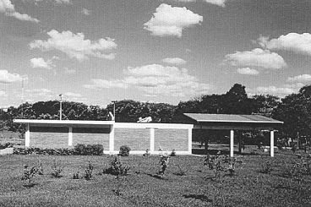
Fig. 2: Sliding-roof type, National University of Asunción, Republic of Paraguay.

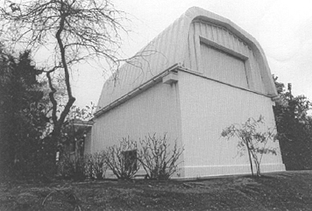

Fig. 3: Sliding-roof type, University of Chile.

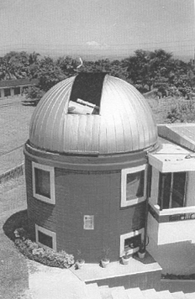
Fig. 4: Dome-type, Philippine Atmospheric Geophysical and Astronomical Service Administration.

- Equipment donated by the Japanese Government from 1986 to 2003

Until the end of the Japanese fiscal year 2003, the following 19 countries and their 24 respective institutions have received the astronomical equipment indicated in the following tables. The application by Peru for a planetarium has been selected for donation in 2004 and is included in the list.

Reflecting telescopes and accessories donated
Year | Reflector size | Receiving institutions/location | Country
1987 | 40-cm | Science Centre | Singapore
1988 | 45-cm | Bosscha Observatory, Institute of Technology, Bandung | Indonesia
1989 | 45-cm | Chulalongkorn University, Bangkok | Thailand
1995 | 45-cm | Arthur C. Clarke Institute for Modern Technologies, near Colombo | Sri Lanka
1999 | 45-cm | Asunción National University | Paraguay
2000 | 45-cm | PAGASA, Quezon City, near Manila | Philippines
2001 | 45-cm | Cerro Calán Astronomical Observatory, University of Chile | Chile

Planetaria donated
Year | Planetarium/location | Country
1986 | Pagoda Cultural Centre, Yangon | Myanmar
1989 | Haya Cultural Centre, Amman | Jordan
1989 | Space Science Education Centre, Kuala Lumpur | Malaysia
1990 | Auxiliary projectors for the already-existing planetarium, Manila | Philippines
1993 | Burdwan University, West Bengal | India
1993 | Auxiliary projectors for the already-existing Planetario de la Ciudad, Buenos Aires | Argentina
1994 | Auxiliary projectors for the already-existing Planetario de la Ciudad, Montevideo | Uruguay
1998 | Ho-Chi Minh Memorial Culture Hall, Vinh City | Viet Nam
1998 | Auxiliary projectors for the already-existing planetarium, Bangkok | Thailand
1998 | Auxiliary projectors for the already-existing planetarium, Colombo | Sri Lanka
1999 | Anna Science Centre, Chennai | India

Planetaria donated (continued)
Year | Planetarium/location | Country
2000 | City Park, Tashkent | Uzbekistan
2001 | Asunción National University | Paraguay
2002 | Planetario Municipal, Cuenca | Ecuador
2002 | Children Museum, San Pedro Sula | Honduras
2002 | Plaza de la Cultura, Santo Domingo | Dominican Republic
2003 | National Costa Rica University, San Jose | Costa Rica
2004 | Laboratorio Central del Instituto Geofísico, Lima | Peru

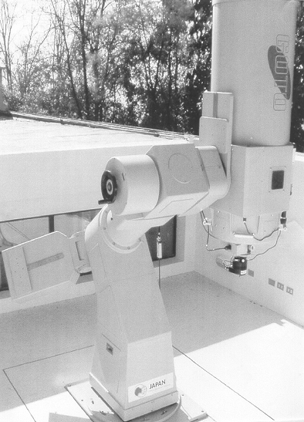

Fig. 5: 45-cm reflector for CCD observation with robotic function donated to the University of Chile.

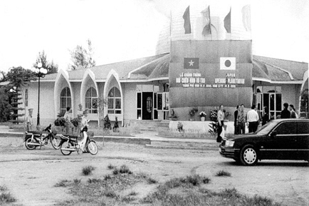

Fig. 6: Planetarium Dome at Ho Chi Minh Memorial Culture Hall, Vinh City,

Viet Nam.

Japan’s Contribution to UN Programmes of Promoting Astronomy and
Basic Space Science in Developing Countries Marks Tenth Year Anniversary
UNIS/OS/224

6 February 2001

VIENNA, 6 February (UN Information Service) - Cooperation between Japan and the United Nations in promoting space science programmes in developing countries is marking its tenth year in 2001. Representatives of Japan are expected to receive a special word of praise for the decade long, model-like cooperation during the next session of the Scientific and Technical Subcommittee of the UNs Committee on the Peaceful Uses of Outer Space which begins here on 12 February.

Building on the successes of the past ten years, the Government of Japan, in cooperation with the Vienna-based United Nations Office for Outer Space Affairs, is continuing the establishment of Planetaria and astronomical telescope facilities at universities in developing nations. Japan's initiative is facilitated through Japan's Cultural Grant Aid and General Grant Aid Programmes. Cooperation between leading astronomers from the National Astronomical Observatory of Japan, Tokyo, with their peers in developing countries has been a main driving force for establishing Planetaria and astronomical telescope facilities in developing nations around the world.

Planetaria have been donated to Uzbekistan (2000), India (1999), Sri Lanka (1998), Uruguay (1994), and Argentina (1993). Currently negotiations are on going between the Governments of Costa Rica and Japan to establish a Planetarium at the Universidad de Costa Rica in San Jose.

Astronomical telescopes and supplementary equipment have also been provided by Japan to the Philippines (2000), Paraguay (1999), and Sri Lanka (1995). The Government of Chile is currently negotiating with the Government of Japan the establishment of an astronomical telescope facility at the Cerro Calán Astronomical Observatory at the University of Chile.

These developments follow up on recommendations made at a series of basic space science workshops organized annually since 1991 under the United Nations Programme on Space Applications, implemented by the Office for Outer Space Affairs in cooperation with the European Space Agency (ESA).

The annual Workshops on Basic Space Science are intended to contribute to the worldwide development of astronomy and space science. Such Workshops have been organized in India (1991) and Sri Lanka (1995) for Asia and the Pacific, in Costa Rica (1992), Honduras (1997), and Colombia (1992) for Latin America and the Caribbean, in Nigeria (1993) and Mauritius (to be held in 2001) for Africa, in Egypt (1994) and Jordan (1999) for Western Asia, and in Germany (1996) and France (2000) for Europe.

Other projects considered during the UN/ESA Workshops on Basic Space Science, include:

- The feasibility of the establishment of a World Space Observatory (WSO/UV);
- The Network of Oriental Robotic Telescopes (NORT);
- The annual publication of a newsletter (African Skies/Cieux Africain) for the astronomical community in Africa; and
- The development of educational material to be used in introducing astronomy into education curricula in developing nations at the university level.

Over the past ten years, astronomers and space scientists from 123 United Nations member States participated at or contributed to the success of the UN/ESA Workshops on Basic Space Science.

The workshops were conducted as part of the activities of the United Nations Programme on Space Applications, which promotes awareness of advances in space science and technology and their applications, in developing nations. The Programme conducts annually training courses, seminars, conferences, and workshops on space-related issues. It also administers a long-term fellowship programme for in-depth training of specialists in space science and technology, provides technical advisory services on request and is contributing to the establishment and operation of regional Centres for Space Science and Technology Education, affiliated to the United Nations, around the world with the goal of developing indigenous capabilities.

* * * * *

- Cooperation with the United Nations

The Office for Outer Space Affairs at the United Nations Office at Vienna is concerned with the exploration and peaceful uses of outer space, as well as the worldwide development and promotion of basic space science. One of the most important activities of the Office is to organize annually a series of workshops dealing with astronomy and basic space science in cooperation with several partners, such as the European Space Agency (ESA).

The latest workshop organized by the Office of Outer Space Affairs was held in 2002, in Córdoba, Argentina, where almost 100 astronomers participated from all over the world. As an illustration of cooperation, an interesting presentation was made as an example of joint work by F. Doncel (Paraguay), A. Troche (Paraguay) and T. Noguchi (Japan) entitled "CCD photometry of KZ Hya using the 45-cm reflector of Asunción National Observatory", as shown in pages 35 to 41 of this publication. The reflector was donated by the above-mentioned Japanese ODA. The KZ Hya is a peculiar non-radial pulsating variable (9.46-10.26 in V) with very short period of 0.05911157 days (from recent analysis of T. Noguchi, unpublished).

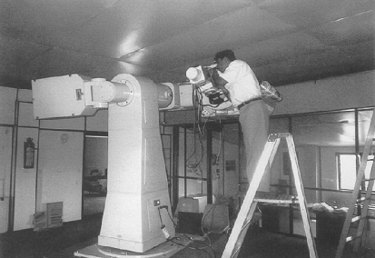

Fig. 7: Sri Lankan astronomer checking and adjusting CCD Camera Spectrograph plus ST-7 for the reflector, at Arthur C. Clarke Institute.

- Follow-up programmes

In order to follow up on the assistance programmes provided to the developing countries in the form of astronomical equipment donations, the Japanese Government is in a position to advise responsible staff and related institutes in a particular country that has successfully received the required equipment. In that way, potential candidates could apply to JICA to receive further technical training by Japanese staff members. This is usually done by applying from the relevant institute directly to the available JICA office in the country. Successful applicants would be able to receive the requested financial help from JICA.

In addition, six-month courses have been carried out regarding follow-up training provided to staff making use of the 45-cm reflectors and accessories such as photoelectric, spectroscopic, and CCD instruments, at the following Public Observatories in Japan, which have available astronomical facilities:

- Bisei Observatory (two staff members from Sri Lanka in 1996 and 1998);
- Nishi-Harima Observatory (one staff member from Paraguay in 2001); and
- Gunma Observatory (one staff member from the Philippines in 2002).

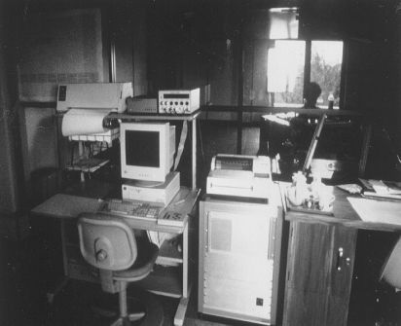

Fig. 8: Console room adjacent to the reflector floor, at Arthur C. Clarke Institute, together with computer set and recorder.

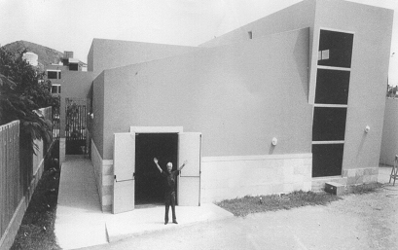

Fig. 9: Planetarium Building at Geophysical Institute, Lima, Peru.

As for the training for a newly installed planetarium, the techniques and strategies for presenting new planetarium show programmes are also taught during such courses to help staff. Also taught are ways to exchange information of such programmes, as well as best management and operation techniques. As an example of a successful follow-up programme involving technical cooperation between Japan and Jordan, Jordanian staff who had been locally trained to use a planetarium donated to Jordan by Japanese ODA came to Tokyo to receive such training at several planetarium institutes.

In order to consolidate these training courses, the Japanese Government, through JICA, is able to provide such technical assistance by sending Japanese senior engineers or technical professionals to developing countries. For example, one senior engineering astronomer from Bisei Observatory was sent to Sri Lanka for helping local staff for a period of two months in 2000. Similarly, the former chief engineering astronomer at Subaru Observatory was sent to Paraguay, not only for technical help, but also for monitoring CCD cameras from 2002 to 2003. The above three cases were also made possible thanks to financial help from JICA’s fund.

Acknowledgements

In the course of processing the ODA applications for requesting assistance for astronomy purposes in developing countries, I have received warm encouragement and kind cooperation from many astronomers, in particular from Professor Y. Fujita, former President of Japan Academy, and Professor Hans Haubold from the Programme on Space Applications of the United Nations Office for Outer Space Affairs. To all of them, I would like to express my sincere gratitude.

References

- Haubold, H., Private Communication on UN Statistics for Astronomical
Instruments Donated from Industrial Countries, 2002.
- Kitamura, M., Astronomical Herald 90, pp. 228. Part I (in Japanese), 1997.
- Kitamura, M., Astronomy for Developing Countries, Special Session at the 24th IAU General Assembly ed. A. Batten, pp. 312, 2001.
- Kitamura, M., Astronomical Herald 96, pp. 428. Part II (in Japanese), 2003.
- Kogure, T., Astronomical Herald 90, pp. 277 (in Japanese), 1997.
- United Nations Information Service, UNIS/OS/224, 2001.

* This paper was written by Professor Emeritus Masatoshi Kitamura for the Office for Outer Space Affairs and highlights Japan’s contribution to the United Nations programme for the promotion of astronomy and basic space science in developing countries.
Unfortunately, Professor Alex Troche suddenly passed away just one month before the workshop took place, after he himself had worked devotedly to establish the first Astronomical Observatory of Paraguay.

