CCD photometry of KZ Hya using the 45-cm

telescope in Paraguay

Fredy Doncel, Alexis Troche and Takeshi Noguchi
Universidad Nacional de Asunción, Facultad Politécnica, Observatorio Astronómico

Abstract

A SX Phe-type pulsating variable KZ Hya (HD94033) was observed with a charge-coupled device (CCD) set attached to the 45-cm reflector at Asuncion Astronomical Observatory in Paraguay. In the present work, 12 maximum phases were covered. A new ephemeris has been obtained, and the result suggests a probable change of the pulsation period of KZ Hya.

- Introduction
CCD photometric observations of KZ Hya (α=10^{h}51^{m}54.08^{s}, δ=-25^{deg}21^{m}10.8^{s}, 2000 ) were made for 7 nights from April 18 to July 17, 2002, with the 45-cm reflector ( made by Goto ) at Asuncion Astronomical Observatory ( Longitude=57^{deg}31^{m}27^{s}W, Latitude=-25.^{deg}20^{m}16^{s}, h=25m ) in Paraguay. KZ Hya was first discovered in 1975 by Przybylski and Bessell (1979 ) in photometric survey of early type stars with high proper motion, and was the first known short period cepheid that clearly belongs to Population II.

A photograph of the 45-cm telescope is shown in Figure 1, and the Observatory building with sliding roof is shown in Figure 2.

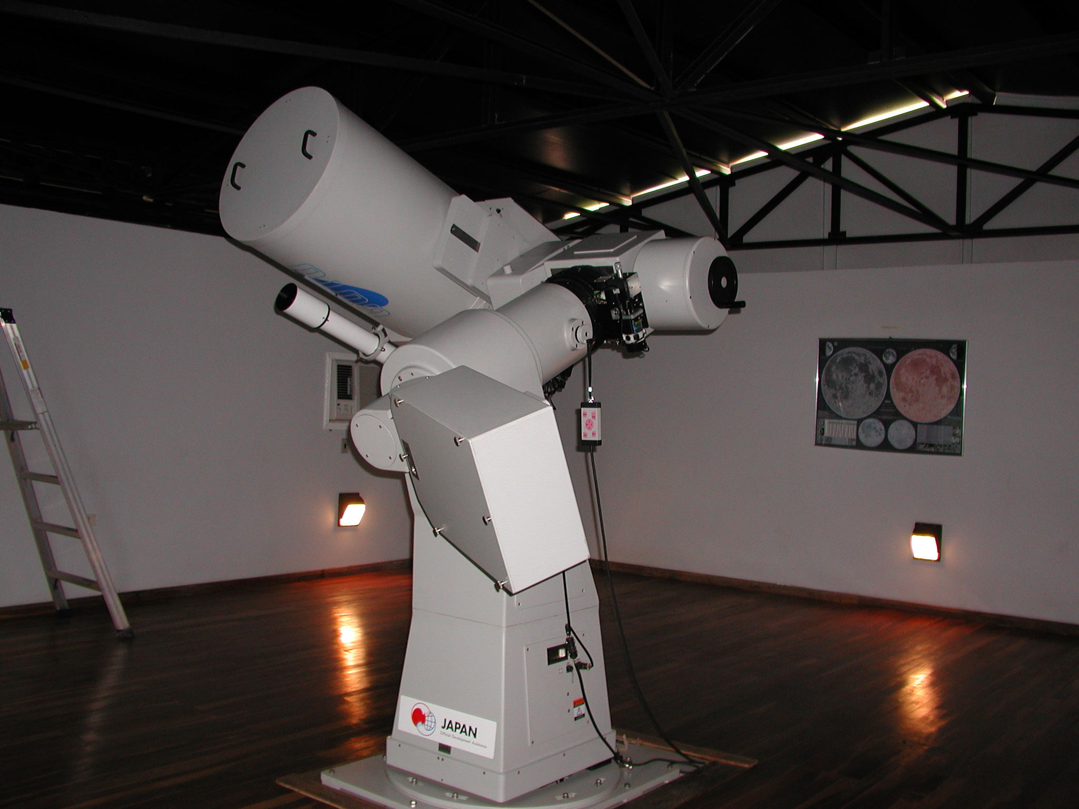
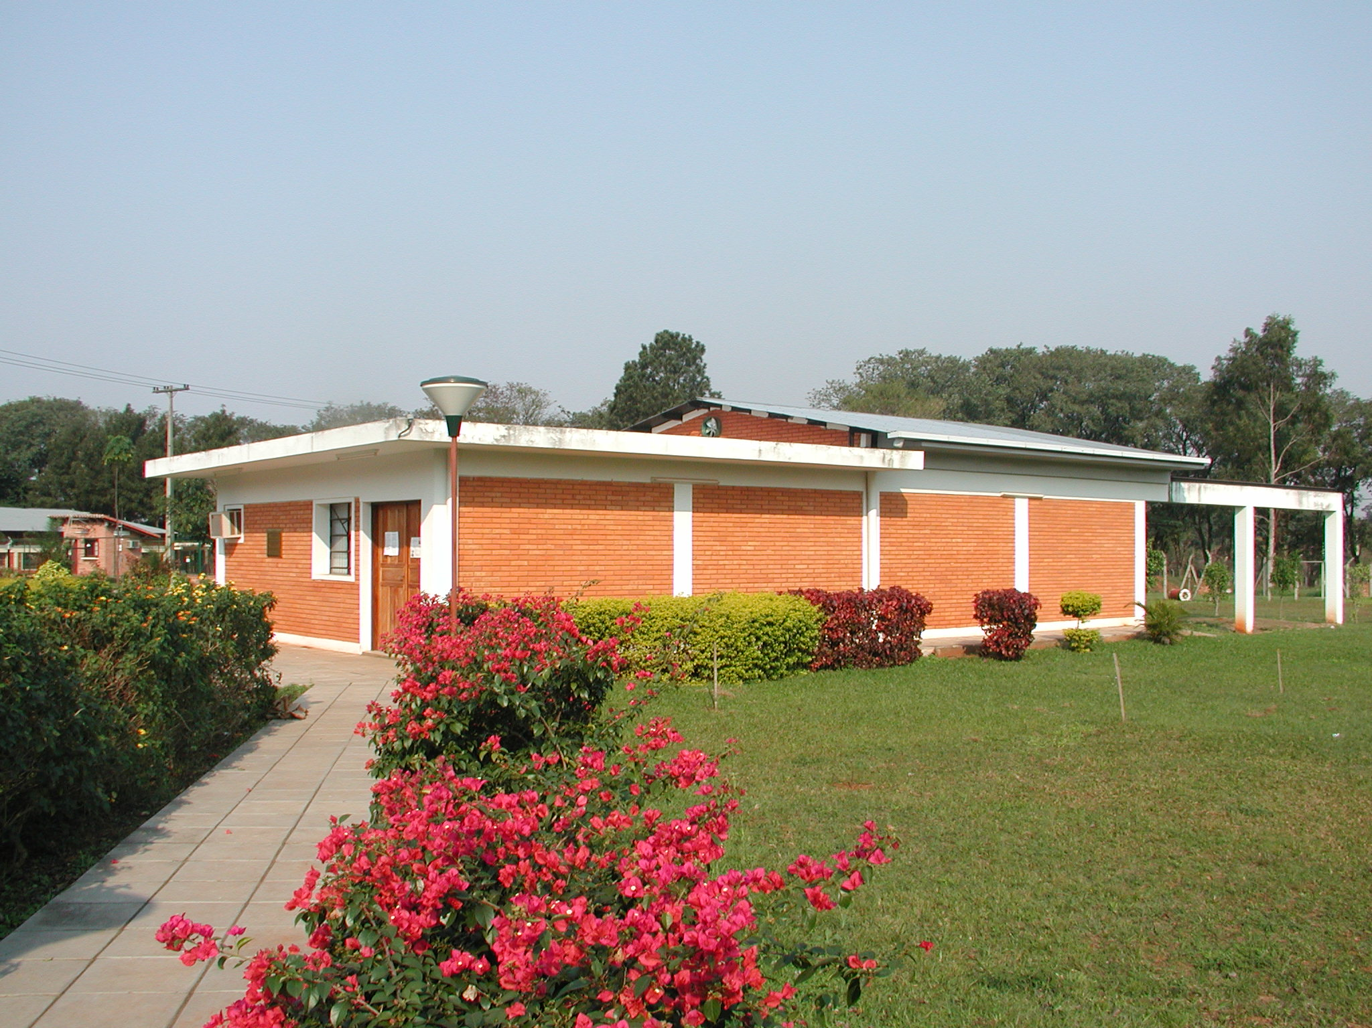

Figure 1. The 45-cm telescope at Asuncion Observatory.
Figure 2. The Observatory building with a sliding roof.

2. Observation and reduction
Observations of KZ Hya were carried out using CCD camera with Blue, Visual, Red, Infrared (BVRI) colour filters, attached to the Cassegrain focus of the 45-cm telescope. The present ST-8 type CCD camera has 1530×1020 pixels, with a field of view of about 8.7×5.8 square arc-minutes, whose system was made by Santa Barbara Instrument Group (SBIG).
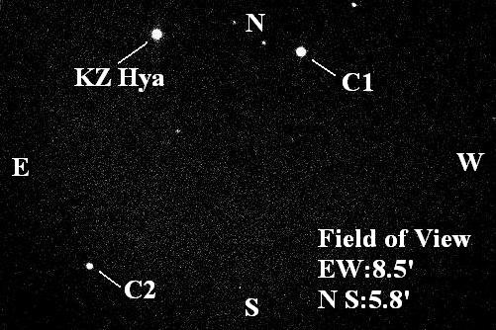
Figure 3 shows the finding chart for KZ Hya. The coordinates (α,δ) and BVRI colour magnitudes

Figure 3. The finding chart for KZ Hya.

of comparison stars are shown as follows:
C1: α(2000)=10 ^{h}50 ^{m} 42.97 ^{s}, δ (2000)=-25 ^{deg}21 ^{m}25.74 ^{s}, B=10.58, V=10.07, R=9.87, I=9.27
C2: α(2000)=10 ^{h}50 ^{m}58.34 ^{s}, δ (2000)=-25 ^{deg}25 ^{m}18.91 ^{s}, B=12.78, V=12.30, R=12.11, I=11.45

Figure 4 shows the result of CCD photometry on the night of 8 May, 2002 as an example. Exposure times of the used colour-bands BVRI were 30 second (B-band), 10 second (V-band), 10 second (R-band), and 10 second (I-band), respectively. The obtained differential magnitudes against the comparison star C1 elected nearby are shown in Figure 4. The C1 star was further checked against another comparison star C2 with the estimated accuracy of less than ±0.02 magnitude for the respective colours. In the present observations, the limiting magnitudes in BVRI for the exposure of 10 seconds are 13 mag. (B), 14 mag.(V), 15 mag. (R), and 15 mag. (I) respectively.

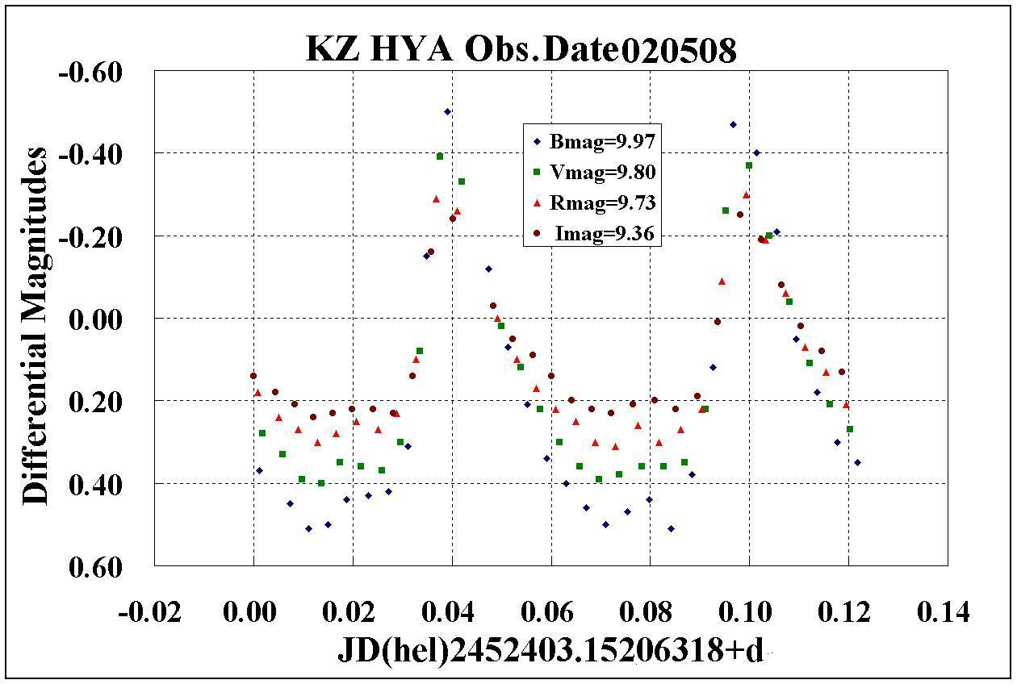

Figure 4. The observation of CCD photometry of the KZ Hya with BGRI colours which were made on the night of 8 May, 2002.

Figure 5 shows differential observations in R colour-band during the 4 nights covering 7 phases with phase shift corresponding at maximum. It further demonstrates that the light curve is asymmetrical at bright-up phase and darkening phase, and there is a secondary maximum at phase 0.7.
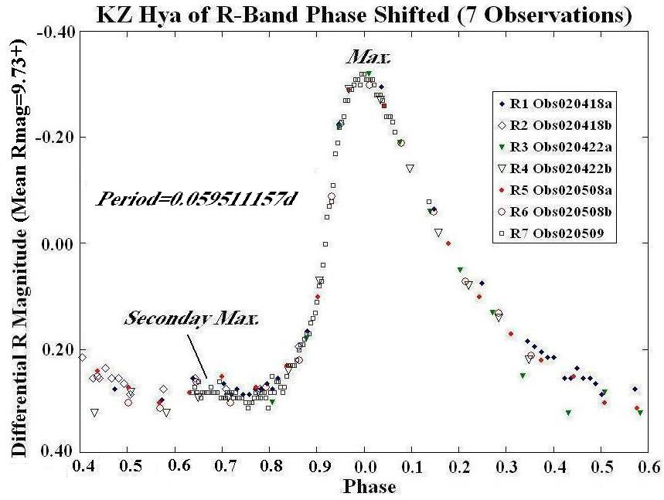

Figure 5. Differential observations in R color during 4 nights covering 7 maximum phases.

Therefore, KZ Hya is probably a multi-component star.

The results for the obtained 12 maximum phases and magnitudes in BVRI colours at the respective maximum and minimum phases are given in Table I. The colour amplitudes of KZ Hya are B=0.993, V=0.792, R=0.624, and I=0.478 respectively.

Table I. Observational properties of KZ Hya

Time of maximum. Phase  JD(hel) 2400000+ |  | Maximum phase magnitudes |  |  |  | Minimum phase magnitudes
 |  | B | V | R | I | B | V | R | I
1  2  3  4  5  6  7  8  9  10  11  12 | 52383.19814255  52383.25763788  52387.18435768  52387.24431098  52403.19128178  52403.25020922  52404.20290673  52445.08858469  52445.14509862  52445.20710371  52464.13027946  52473.11587176 | 9.465  9.448  9.468  9.457  9.463  9.473  9.485  9.473  9.463 | 9.389  9.394  9.400  9.390  9.397  9.397  9.397  9.407  9.392  9.394 | 9.401  9.406  9.399  9.398  9.411  9.411  9.403  9.411  9.401  9.416  9.404  9.403 | 9.114  9.106  9.114  9.104  9.113  9.110  9.131  9.118  9.111  9.111  9.109 | 10.459  10.465  10.485  10.457  10.468  10.468  10.453  10.438  10.448  10.453 | 10.199  10.192  10.190  10.186  10.197  10.179  10.187  10.182  10.177  10.192 | 10.033  10.028  10.038  10.039  10.028  10.023  10.034  10.026  10.031  10.016  10.026  10.026 | 9.584  9.598  9.591  9.604  9.591  9.593  9.581  9.591  9.588  9.591
Average |  | 9.467 | 9.395 | 9.405 | 9.112 | 10.460 | 10.188 | 10.029 | 9.591
Standard deviation |  | 0.011 | 0.005 | 0.006 | 0.007 | 0.013 | 0.007 | 0.006 | 0.006
3. Period of pulsation
From their first observational results of 25 maximum phases, Przybylski and Bessell (1979), reduced the following ephemeris,
T max(hel) = 2442516.15836 + 0.0595104212 E, ………………………………………(1)

while Hobart, Peniche and Pena (1985), gave
T max(hel) = 2442516.15903 + 0.0591012 E, ………………………………………(2)

and also Liu, Jiang and Cao (1991), gave
T max(hel) = 2442516.15576 + 0.05911036 E +0.5×2.92⁻¹² E² . ……………………………(3)

A new determination of the ephemeris has been made, 102 maximum phases combining the present result (hereinafter DTN) with the previous ones, which can cover 27 years altogether. Using the O-C residuals of all maximum phase values obtained so far, a new ephemeris can be obtained as,
T max(hel) = 2442516.15850 + 0.05911157 E +0.5×2.24⁻¹² E² . ……………………………(4)

The results time of light maximum and O-C residuals for KZ Hya are given in Table II. In this Table, LJC(O-C) and DTN(O-C) residuals are obtained using equation (3) and (4) respectively, and the column of Ref numbers are shown as the following;
Ref 1. Przybylski and Besell (1979),
Ref 2. Hobart, Peniche and Pena (1985),
Ref 3. McNamara and Budge (1985),
Ref 4. Liu, Jiang and Cao (1991, hereinafter LJC),
Ref 5. DTN.

Table II. Time of light maximum and O-C residuals for KZ Hya

No. | T Max(hel) | E | LJC | DTN | Ref | No. | T Max(hel) | E | LJC | DTN | Ref
 | JD2400000+ |  | (O-C) | (O-C) |  |  | JD2400000+ |  | (O-C) | (O-C)
1 | 42516.15850 | 0 | 0.00274 | 0.00000 | 1 | 44 | 45749.93870 | 54339 | 0.00844 | 0.00013 | 2
2 | 42517.94395 | 30 | 0.00286 | 0.00012 | 1 | 45 | 45750.95030 | 54356 | 0.00835 | 0.00004 | 2
3 | 42518.00344 | 31 | 0.00284 | 0.00009 | 1 | 46 | 45751.72430 | 54369 | 0.00871 | 0.00039 | 2
4 | 42518.12234 | 33 | 0.00272 | -0.00003 | 1 | 47 | 45769.75640 | 54672 | 0.00892 | 0.00058 | 2
5 | 42541.92655 | 433 | 0.00251 | -0.00028 | 1 | 48 | 45769.81580 | 54673 | 0.00880 | 0.00047 | 2
6 | 42541.98593 | 434 | 0.00238 | -0.00041 | 1 | 49 | 45769.87500 | 54674 | 0.00849 | 0.00015 | 2
7 | 42542.04475 | 435 | 0.00169 | -0.00110 | 1 | 50 | 45770.64790 | 54687 | 0.00775 | -0.00059 | 2
8 | 42542.10445 | 436 | 0.00188 | -0.00091 | 1 | 51 | 45770.70770 | 54688 | 0.00804 | -0.00030 | 2
9 | 42542.87873 | 449 | 0.00251 | -0.00028 | 1 | 52 | 45770.76740 | 54689 | 0.00823 | -0.00011 | 2
10 | 42542.93822 | 450 | 0.00249 | -0.00030 | 1 | 53 | 45776.71850 | 54789 | 0.00821 | -0.00014 | 2
11 | 42542.99729 | 451 | 0.00205 | -0.00074 | 1 | 54 | 45777.66990 | 54805 | 0.00743 | -0.00092 | 2
12 | 42543.89034 | 466 | 0.00244 | -0.00036 | 1 | 55 | 45777.73030 | 54806 | 0.00832 | -0.00003 | 2
13 | 42544.00938 | 468 | 0.00245 | -0.00034 | 1 | 56 | 45782.66990 | 54889 | 0.00849 | 0.00013 | 2
14 | 42545.91375 | 500 | 0.00247 | -0.00033 | 1 | 57 | 45782.72940 | 54890 | 0.00848 | 0.00012 | 2
15 | 42545.97289 | 501 | 0.00210 | -0.00070 | 1 | 58 | 45782.78900 | 54891 | 0.00856 | 0.00021 | 2
16 | 42562.99304 | 787 | 0.00209 | -0.00074 | 1 | 59 | 45782.84850 | 54892 | 0.00855 | 0.00020 | 2
17 | 42755.21105 | 4017 | -0.00057 | -0.00379 | 1 | 60 | 45783.68120 | 54906 | 0.00810 | -0.00026 | 2
18 | 42846.97670 | 5559 | -0.00095 | -0.00436 | 1 | 61 | 45783.74100 | 54907 | 0.00838 | 0.00003 | 2
19 | 42847.09585 | 5561 | -0.00083 | -0.00423 | 1 | 62 | 45783.80000 | 54908 | 0.00787 | -0.00049 | 2
20 | 42847.15502 | 5562 | -0.00117 | -0.00457 | 1 | 63 | 45784.69350 | 54923 | 0.00871 | 0.00035 | 2
21 | 42890.06282 | 6283 | -0.00084 | -0.00432 | 1 | 64 | 45784.75270 | 54924 | 0.00839 | 0.00003 | 2
22 | 42890.95528 | 6298 | -0.00104 | -0.00453 | 1 | 65 | 45784.81250 | 54925 | 0.00868 | 0.00032 | 2
23 | 42891.96642 | 6315 | -0.00159 | -0.00508 | 1 | 66 | 45792.66600 | 55057 | 0.00671 | -0.00167 | 2
24 | 42929.99391 | 6954 | -0.00166 | -0.00523 | 1 | 67 | 45793.20370 | 55066 | 0.00880 | 0.00043 | 4
25 | 42958.91607 | 7440 | -0.00188 | -0.00550 | 1 | 68 | 45793.26290 | 55067 | 0.00849 | 0.00012 | 4
26 | 43601.69310 | 18241 | -0.00395 | -0.00879 | 3 | 69 | 45793.67920 | 55074 | 0.00821 | -0.00016 | 2
27 | 43604.66880 | 18291 | -0.00381 | -0.00865 | 3 | 70 | 45795.04880 | 55097 | 0.00906 | 0.00068 | 4
28 | 44664.27200 | 36096 | 0.00398 | -0.00268 | 4 | 71 | 45795.10730 | 55098 | 0.00805 | -0.00033 | 4
29 | 44690.09970 | 36530 | 0.00385 | -0.00286 | 4 | 72 | 45795.16700 | 55099 | 0.00824 | -0.00014 | 4
30 | 44690.15930 | 36531 | 0.00394 | -0.00277 | 4 | 73 | 45795.64310 | 55107 | 0.00825 | -0.00013 | 2
31 | 44691.11090 | 36547 | 0.00336 | -0.00335 | 4 | 74 | 45796.06060 | 55114 | 0.00917 | 0.00079 | 4
32 | 44691.17050 | 36548 | 0.00345 | -0.00326 | 4 | 75 | 45796.11940 | 55115 | 0.00846 | 0.00008 | 4
33 | 45383.29040 | 48178 | 0.00856 | 0.00078 | 4 | 76 | 45796.17930 | 55116 | 0.00884 | 0.00047 | 4
34 | 45384.18340 | 48193 | 0.00889 | 0.00111 | 4 | 77 | 45798.67850 | 55158 | 0.00857 | 0.00019 | 2
35 | 45384.24300 | 48194 | 0.00898 | 0.00120 | 4 | 78 | 45800.64220 | 55191 | 0.00840 | 0.00002 | 2
36 | 45748.74790 | 54319 | 0.00787 | -0.00044 | 2 | 79 | 45808.61680 | 55325 | 0.00850 | 0.00011 | 2
37 | 45748.80810 | 54320 | 0.00856 | 0.00025 | 2 | 80 | 45808.67610 | 55326 | 0.00829 | -0.00010 | 2
38 | 45748.86710 | 54321 | 0.00805 | -0.00026 | 2 | 81 | 45808.73580 | 55327 | 0.00848 | 0.00009 | 2
39 | 45748.92780 | 54322 | 0.00923 | 0.00092 | 2 | 82 | 45854.49890 | 56096 | 0.00747 | -0.00099 | 3
40 | 45748.98610 | 54323 | 0.00802 | -0.00029 | 2 | 83 | 45856.46120 | 56129 | 0.00590 | -0.00256 | 3
41 | 45749.76080 | 54336 | 0.00908 | 0.00077 | 2 | 84 | 46153.06520 | 61113 | 0.00604 | -0.00282 | 4
42 | 45749.81990 | 54337 | 0.00867 | 0.00036 | 2 | 85 | 46153.12980 | 61114 | 0.01113 | 0.00227 | 4
43 | 45749.87950 | 54338 | 0.00876 | 0.00044 | 2 | 86 | 46501.20140 | 66963 | 0.00159 | -0.00773 | 4

Table II. (Continued) Time of light maximum and O-C residuals for KZ Hya

No. | T Max(hel) | E | LJC | DTN | Ref | No. | T Max(hel) | E | LJC | DTN | Ref
 | JD2400000+ |  | (O-C) | (O-C) |  |  | JD2400000+ |  | (O-C) | (O-C)
87 | 46503.16500 | 66996 | 0.00132 | -0.00800 | 4 | 95 | 52403.19127 | 166137 | 0.01022 | -0.00324 | 5
88 | 46503.22480 | 66997 | 0.00161 | -0.00771 | 4 | 96 | 52403.25019 | 166138 | 0.00963 | -0.00382 | 5
89 | 46889.15480 | 73482 | 0.00121 | -0.00859 | 4 | 97 | 52404.20291 | 166154 | 0.01016 | -0.00329 | 5
90 | 48398.15100 | 98838 | 0.02920 | 0.01782 | 4 | 98 | 52445.08858 | 166841 | 0.01143 | -0.00204 | 5
91 | 52383.19813 | 165801 | 0.01296 | -0.00050 | 5 | 99 | 52445.14510 | 166842 | 0.00843 | -0.00503 | 5
92 | 52383.25763 | 165802 | 0.01294 | -0.00052 | 5 | 100 | 52445.20710 | 166843 | 0.01092 | -0.00254 | 5
93 | 52387.18435 | 165868 | 0.01190 | -0.00156 | 5 | 101 | 52464.13028 | 167161 | 0.00943 | -0.00403 | 5
94 | 52387.24430 | 165869 | 0.01234 | -0.00112 | 5 | 102 | 52473.11587 | 167312 | 0.00879 | -0.00468 | 5

Two series of O-C residuals (LJC, DTN) versus epochs for KZ Hya are shown in Figure 6. An estimation of ephemeris accuracy is about 0.0001 days, and therefore, any change of the pulsating period is suspected because it is found to be about 5 times larger than the accuracy of measurements. Also, Figure 6 shows that the DTN O-C residuals curve exhibit regular variation with a long period of about 9 years. Therefore, the present result needs to be understood by additional theoretical modelling.
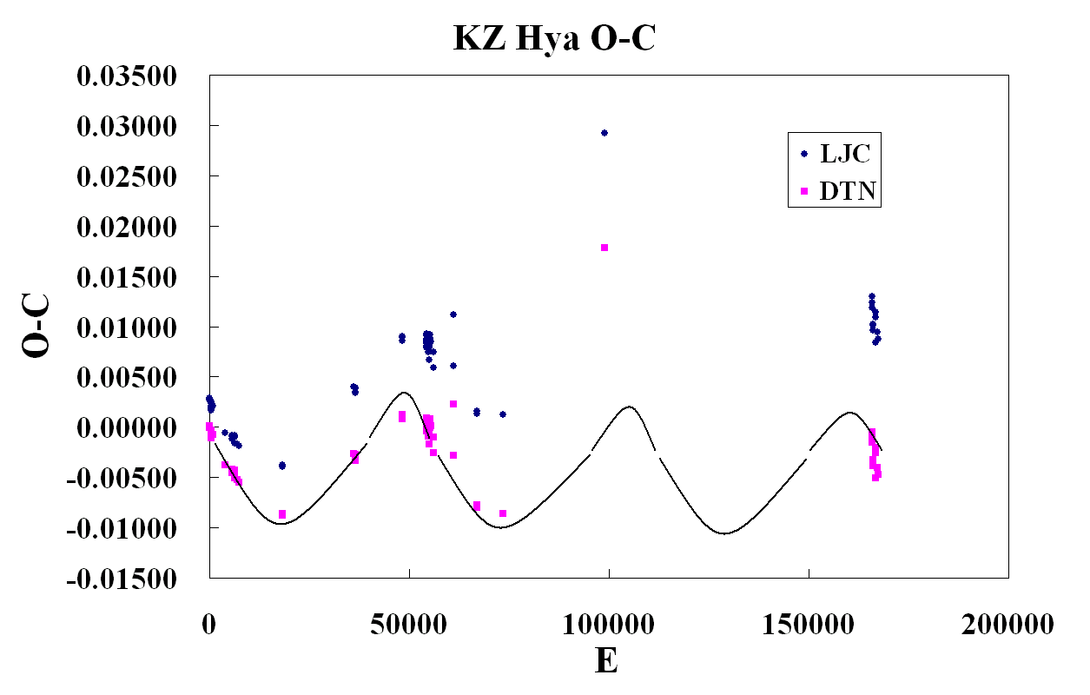

Figure 6. O-C residuals versus epochs for KZ Hya

4. Two-colour diagram

The colour diagram between B-V and R-I obtained from the present observations can be shown in Figure 7, where the smoothed mean colour curve is used in the reduction. During the rapid rise of bright-up phases and the following darkening phases the star appears to move anticlockwise on this diagram. The separation of the right–hand side and left-hand side around maximum parts are larger than that around the minimum parts. Figure 7 shows that the curve at phases of 0.6, 0.7, 0.8 and that at phases of 0.3, 0.4, 0.5 seem to approach each other and eventually twist at the lower part, while the curve at bright up phases 0.9 to 0.0, the R magnitude rapidly goes up after 0.0 phase to 0.3 darkening.

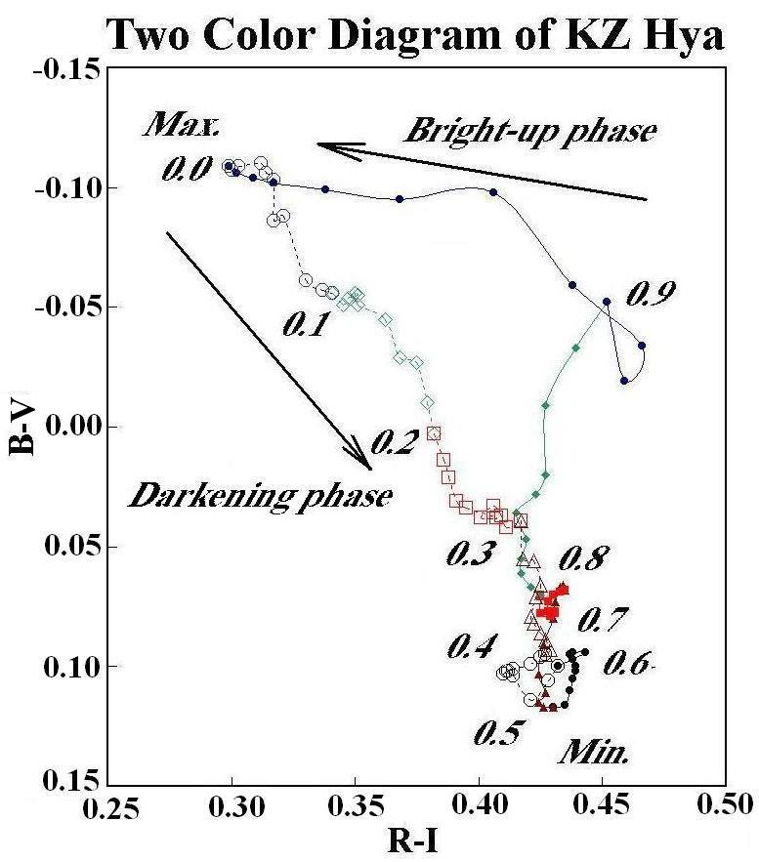

Figure 7. Two colour diagram, B-V versus R-I.

5. Conclusion
The present CCD photometric observations were obtained by covering 12 maximum epochs. A new ephemeris has been obtained, and the result can suggest a possible change of the pulsation period of KZ Hya.
Finally, this paper is the first result of CCD photometry using the 45-cm telescope at Asuncion Observatory.

Acknowledgements: We would like to express our hearty thanks to Professor M. Kitamura and Dr. M. Kondo of the National Astronomical Observatory of Japan for their helpful discussions. Thanks are also due to Mr. H. Sato of the same Observatory for his kind help. In the present work, TN acknowledges the partial financial support from Japan International Cooperation Agency (JICA).

References

Hobart,M.A., Peniche, R. and Pena, J.H. 1985, Rev.Mexicana Astron. Astrof., 11, 19-21.
Liu, Yanying, Jiang, Shiyang and Cao, Ming 1991, Inf. Bull. Var.Stars No.3606.
McNamara,D.H., and Budge, K.G. 1985, Publ.Astron.Soc.Pacific, 97, 322-327.
Przybylski, A. and Bessell, M.S. 1979, Mon.Not.R.astr.Soc., 189, 377-385.

