PROPOSED ORBITAL SPACE MISSION
UNOOSA CALL FOR INTEREST FOR LANDING SITE

Summary
The United Nations Office for Outer Space Affairs (UNOOSA) has been collaborating with the Sierra Nevada Corporation (SNC), since 2016, to offer United Nations Member States the opportunity to participate in an orbital space mission utilizing SNC’s Dream Chaser® space vehicle. The mission will be open to all Member States of the United Nations and institutions and entities therein. Developing countries and their institutions and entities are particularly encouraged to participate. The mission will carry experiments, payloads, or satellites provided by institutions in the participating countries.

The Dream Chaser® space vehicle can land on any commercial runway that meets the following requirements:

- Minimum of 10,000 ft in length;
- Minimum of 150ft in width;
- Isolated location off runway for vehicle-related safety operations;
- Hangar available for Dream Chaser post landing operations.
  - Minimum door height of 20 ft
  - Minimum door width of 35 ft
  - Minimum square footage of 5500 ft²

The purpose of this Call for Interest is to invite those Member States and their institutions and entities potentially interested in hosting the landing of this mission, to indicate interest and/or intent in doing so.

This mission will be the first international space mission devoted to addressing the Sustainable Development Goals.

Introduction
The mission of UNOOSA is to promote international cooperation in the use of outer space to achieve development goals for the benefit of humankind. There is no better example of UNOOSA’s vision “to bring the benefits of space to humankind” by showing space’s importance in the realization and implementation of the 17 Sustainable Development Goals shown in Figure 1.

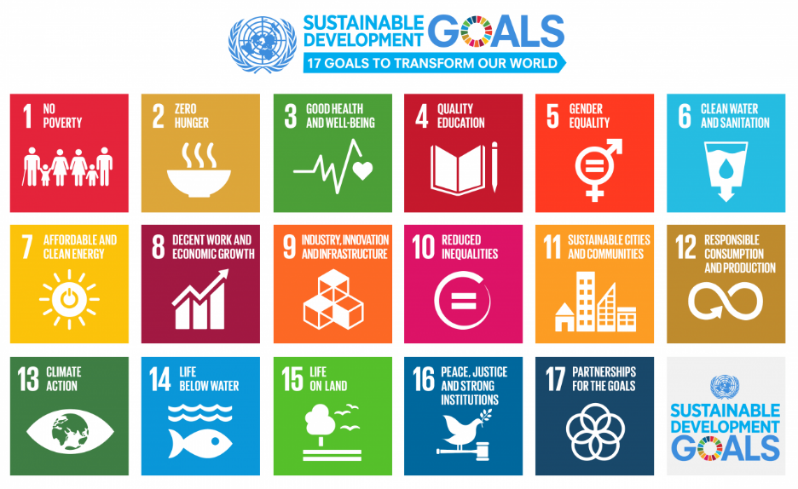
Figure 1: Sustainable Development Goals
UNOOSA intends to utilize the technological and innovative skills of the private sector to benefit developing countries and to deliver the “Access to Space for All’’ initiative to address all 17 Sustainable Development Goals. For the proposed Orbital Space Mission, UNOOSA has been working with SNC under an agreement signed in 2016 to define a dedicated space mission that would utilize SNC’s Dream Chaser® space vehicle and could carry 20-30 experiments/payloads developed by institutions in Member States of the United Nations, with particular attention to developing and countries. In addition to addressing the 17 Sustainable Development Goals, a key aspect of the mission is to provide training and facilitate development of know-how at the national level in the practical applications of space technology, in particular for developing countries.

Who is invited to answer this call?
This Call for Interest is aimed at all Member States of the United Nations, as well as entities and institutions in these States, who are able to host landing and to provide a runway at least 10,000 feet long by 150 feet wide.

The potential worldwide interest to the orbital mission prepared by UNOOSA and SNC
The landing of the orbital mission is anticipated to be a major worldwide event. It will give a great exposure to the hosting Member State and the landing site, and represents an opportunity for multiple benefits to the region, not only in terms of direct economic value of visitors to the event, but also in terms of raising the profile of the region, increasing interest in STEM (Science, Technology, Engineering, and Mathematics) education, and forging relationships for future space missions. Responders to this Call for Interest are kindly invited to provide a preliminary description of the vision of how the event could be organized and promoted.

Licenses and authorizations
The selected Member State and/or its institution/entity which will host the landing site will need to ensure its full compliance under the local legislation, and also to seek, with the assistance of SNC, from the Federal Aviation Administration (United States of America) Part 435 re-entry license which is required for landing the vehicle anywhere in the world. Cost of the activities for obtaining all required licenses will be borne by the awardee. Given that public safety is one of the primary considerations in re-entry and site licensing, runways located by significantly large populations may present challenging in the licensing process, and it is important to take this factor into consideration when preparing the application.

UNOOSA CALL FOR INTEREST FOR LANDING SITE

Name:
Mailing Address:
Phone Number:
Email:
Member State:
Organization/Agency/Company:

Are you interested in participating in this opportunity? |  Yes   No   Need more information
If “Yes”, please describe what about this opportunity is of greatest interest
If “Need”, please describe what additional information you would like to receive. A briefing after the CFI is closed will be organized.
Please describe any ideas you have to help raise the profile of the landing event.
Any concerns or areas that you believe will be challenging from a licensing perspective? (e.g. public safety impacts, airspace impacts, etc.)
Frequency of runway/airport use
Runway Elevation
Runway Surface Material
Runway Width (In feet)
Runway Length (in feet)
Runway headings
Airport Identifier
Runway Diagram
Hangar Specification (Door height, Door width, square footage available)
Does the airport have multiple runways? |  Yes   No
Do you have governmental support? |  Yes   No   Unknown
If you have governmental support, please describe:
Do you have an anticipated funding source for this opportunity? |  Yes   No   Unknown
Do you have any other questions or comments?
A briefing after the CFI is closed will be organized.

Please complete and submit this form to:

oosa@un.org

Latest by 30 April 2020 at 23:59 CET. If you are interested in submitting an expression of interest, we would be grateful if you could send us a letter of intent by 31 January.

ANNEX: Technical information
Knowing more about the Dream Chaser: Dream Chaser Description
Sierra Nevada Corporation’s (SNC) Space Systems, a business area of aerospace and defense company SNC, is the owner and developer of the Dream Chaser spacecraft, a multi-mission, reusable, Space Utility Vehicle (SUV).

The Dream Chaser space vehicle has been developed by SNC to be a crewed or uncrewed space vehicle that can access low-Earth orbit (LEO). In 2016, NASA selected SNC to use an uncrewed version of the vehicle to carry cargo to and from the International Space Station (ISS) under the Commercial Resupply Services contract that provides for cargo missions to the ISS from 2019 to 2024. The vehicle is capable of carrying both pressurized and unpressurized cargo, including powered payloads, to the ISS, and of returning science payloads to Earth, implementing a runway landing, similar to the space shuttle, allowing immediate access to payloads. The figure below displays the major elements of the Dream Chaser spacecraft, specifically the lifting body vehicle, which is the portion that returns to Earth, and the Cargo Module (CM), which can carry an array of pressurized and unpressurized payloads to space and is disposed of during re-entry.

SNC’s Dream Chaser spacecraft is the only low-Earth orbit, reusable, lifting-body vehicle capable of a
runway landing and immediate access to cargo – preserving, continuing and improving upon 40+ years of space shuttle and lifting-body heritage into a mature 21st Century system. The Dream Chaser Cargo System builds upon more than 10 years of development maturation, including more than five years as part of the public-private partnership between SNC and NASA under the Commercial Crew Program.

The innovative design of the Dream Chaser, including deployable wings, allows the spacecraft to fit
inside a standard fairing. The autonomous Dream Chaser Cargo System meets all of NASA’s Commercial Resupply Services 2 (CRS2) mission requirements for pressurized and unpressurized cargo delivery, disposal and accelerated return. In early 2016, SNC was awarded a contract to provide a minimum of six missions to the ISS under CRS2. The vehicle is designed for high reusability, reducing overall cost and providing rapid turnaround for re-flight opportunities.

The advantages of the Dream Chaser spacecraft extend well beyond ISS resupply. For the purpose of this CFI, these advanced development opportunities include: free flight science missions, orbital debris removal, and serving as a test bed for exploration technologies.

Dream Chaser Cargo System Features

- Reusable, lifting-body spacecraft with attached, disposable cargo module;
- Launches inside a standard 5m fairing, allowing for easy adaptation for multiple launch providers;
- Transportation of up to 5,500kg of pressurized/unpressurized upmass to LEO;
- Low-g entry and gentle runway landing protects sensitive payloads from the stressful entry environment experienced by alternate vehicle concepts;
- Non-toxic, non-hypergolic propulsion and fluids system allow late cargo loading and safe/rapid
- access to the vehicle and its payloads post landing;
- Responsive capability with immediate access to payloads upon conventional runway landing, with the majority accessible in just hours and all cargo accessible within 24 hours.

Mission Description
The final Concepts of Operations (CONOPS) will be defined after the experiments/payloads/satellites are selected along with a launch vehicle and landing site. The mission is expected to last 2-3 weeks on orbit at an altitude of about 500km and an inclination between 0 and 40 degrees. The figure below depicts the notional CONOPS.

Dream Chaser provides an array of capabilities aimed to support a wide range of payloads. The major categories of payloads that Dream Chaser can support are:

- Pressurized powered payloads (Items internal to the UDC);
- Pressurized unpowered payloads (Items internal to the UDC, but self-sustaining);
- Unpressurized powered payloads (Items external to the CM and exposed to space);
- Unpressurized deployments (Items external to the CM and deployed to fly on their own).

Quantity of Experiments
This mission will support 20 to 30 powered experiments between the internal and external locations. At the external locations, deployments can also be accommodated.

_________________________________________________________________________________________________________________
DISCLAIMER: The information provided in this Call for Interest (CFI) is not binding. The purpose of this CFI is to establish whether there is
sufficient interest from United Nations Member States in hosting a landing site. At any stage, the mission may be changed, suspended,
cancelled or postponed.

The present Call for Interest serves for the purpose of studying potential interest and level of commitment from interested Member States. Financial aspects of the subject matter of the Call for Interest are to be handled by Sierra Nevada Corporation jointly with the interested member States. The United Nations Office for Outer Space Affairs facilitates the dissemination of the present Call for Interests.
The information provided in this Call for Interest (CFI) is not binding. The purpose of this CFI is to establish whether there is enough interest from the Member States in hosting a landing site. At any stage, the mission may be changed, suspended, cancelled or postponed.

